Princess Sumaya University for Technology

King Abdullah II Faculty of Engineering

Electrical Engineering Department



|  |
| --- |
| **EMBEDDED SYSTEMS (22442)**  **smart conditioning system** |

|  |  |  |  |
| --- | --- | --- | --- |
| *Authors:* |  |  | *Supervisor:* |
| Kareem Farwagi  Sanad Muhyar  Njoud Saleh | 20190078  20190158  20190605 | Power and energy Engineering  Power and energy Engineering  Communications Engineering | Dr. Belal Sababha |

*January 19, 2023*

***Abstract***

*This project is a* ***temperature-controlled fan and heater system with a safety option*** *using infrared sensor. The system is implemented using a PIC16F877A microcontroller with an LCD display, ADC and PWM module. The system continuously* *reads temperature from the ADC, converts it to a readable format and displays it on the LCD screen. The code also includes logic to turn on and off the heater and fan based on temperature readings, and uses PWM to control fan speed. The system also uses an interrupt service routine to handle safety events triggered by the infrared sensor, such as turning off the fan if an object is detected in front of it. The code is written in C programming language and utilizes PORTB, PORTA, and PORTC for input and output. Overall, this project provides a comprehensive guide for implementing a temperature-controlled fan and heater system with safety features.*

Table of Contents

1 Introduction 2

2 Procedure and Methods 2

3 Results and Discussions 3

3.1 Guidelines for a Good Schematic 3,4,5

3.5 Problems and Recommendations 6

4 Conclusions 6

# Introduction

*This project presents a smart conditioning system that is capable of providing optimal cooling or heating conditions based on the current ambient temperature. The system utilizes a temperature sensor to monitor the ambient temperature and activate a fan or heater as necessary. Additionally, the system incorporates a smart safety feature that utilizes an infrared sensor to detect any objects moving close to the system and activate an alarm system composed of a buzzer and LED. This ensures the safety of the user by alerting them to any potential hazards in the vicinity of the system.*

# Procedure and Methods

We focused on achieving these three main points:

* System Design:

The system initializes the LCD display, ADC, and PWM module, and then continuously reads the temperature from the ADC. The temperature data is then converted to a readable format and displayed on the LCD screen.

* Temperature Control:

The code includes logic to turn on and off the heater and fan based on the temperature readings. When the temperature falls below a certain threshold, the heater is turned on to raise the temperature. When the temperature exceeds a certain threshold, the fan is turned on to lower the temperature. The fan speed is also controlled using PWM, allowing for precise adjustments to the airflow.

* Infrared Safety Sensor:

An infrared sensor is used to detect the presence of an object in front of the fan, and an interrupt service routine is used to handle this safety event. If the sensor detects an object, the fan is immediately turned off to prevent injury. The system also displays a warning message on the LCD screen, alerting the user to the safety event.

In the following section, we will discuss the specific components utilized in this project and the methods employed for their successful connection.

1. Four-digit LCD
2. LM35(temperature sensor)
3. nMOS
4. LEDs
5. Buzzer
6. Infrared sensor
7. Mechanical relay
8. Fan/heater

# Results and Discussions

This is an important part of the report. The accompanying graph and schematic are provided to assist in replicating the results we have obtained. They are intended to serve as a guide in achieving similar outcomes.

## Guidelines for a Good Schematic

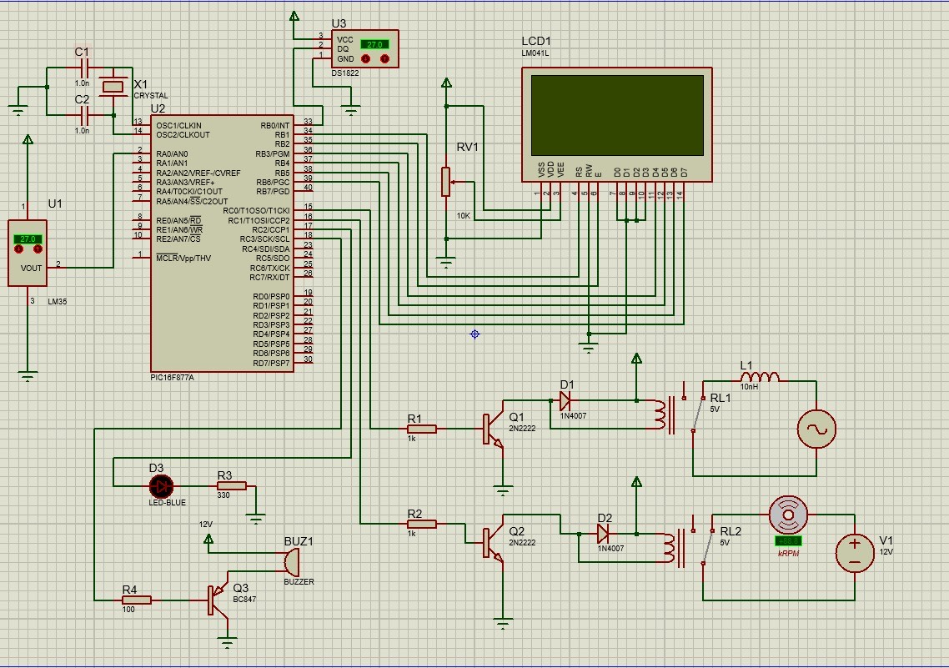

Figure 1: Electrical Schematic of the connected ports with the PIC16F877A

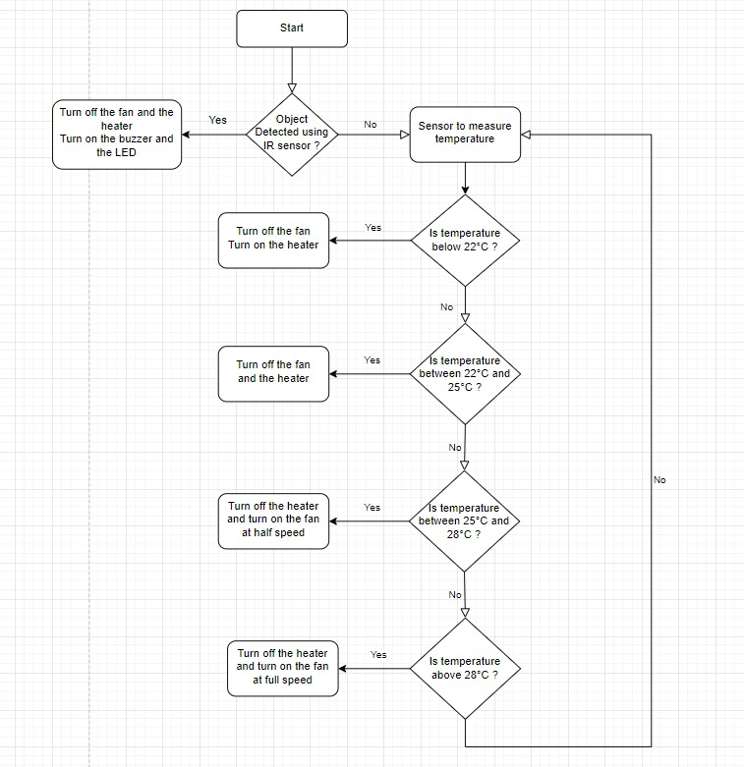

Figure 2: Software Design (Flow Chart)

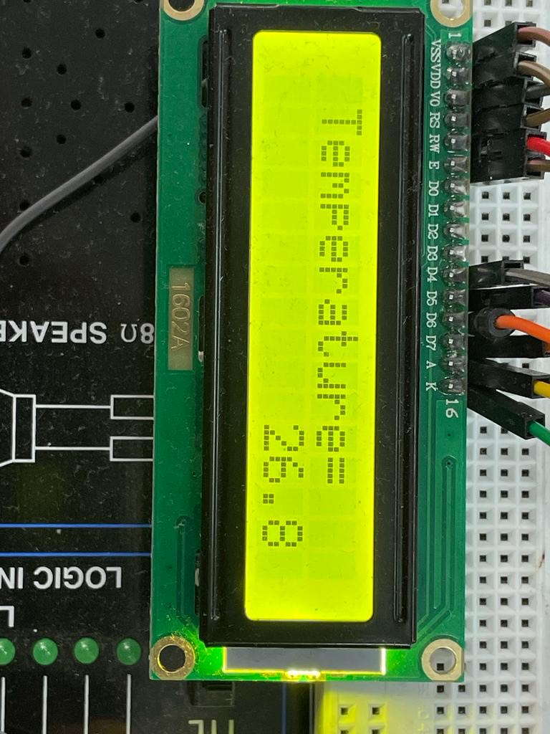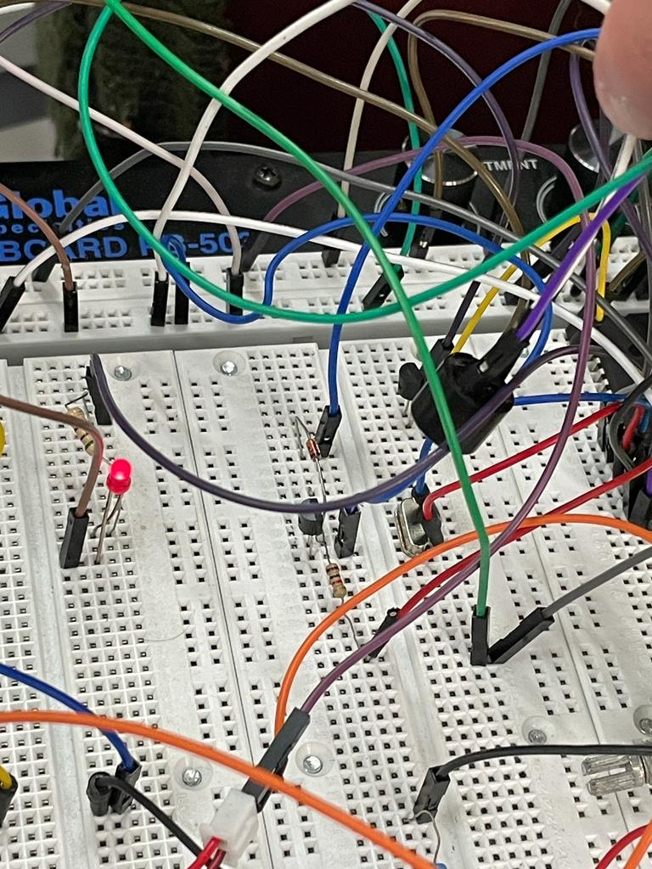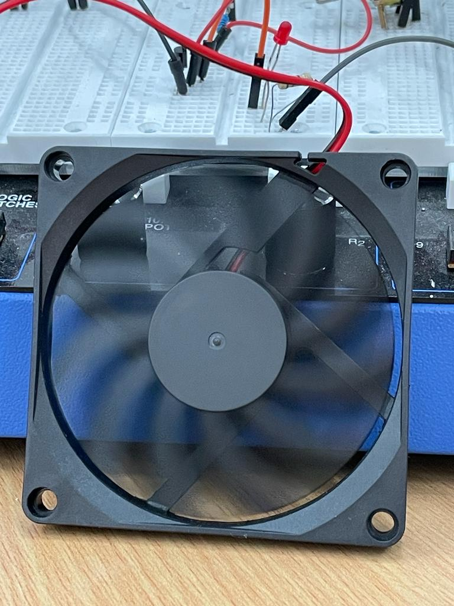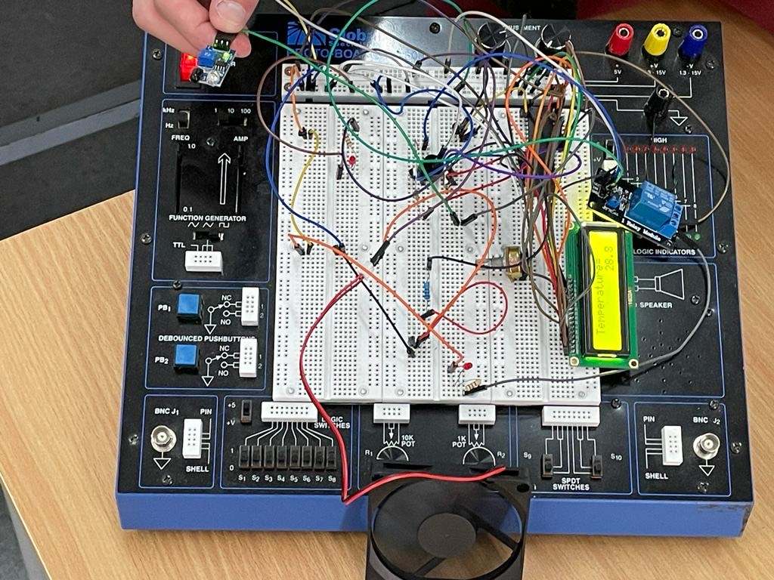

Figure 4: reading temperature continuously from the ADC, converts it to a readable format and displays it on the LCD screen

Figure 3: LED is ON and Buzzer makes noise while infrared detects motion

Figure 5: Fan working on 50% duty cycle when temperature is less than 28 and more than 25

Figure 6: Top view of the mechanical design

## problems and recommendations

* We attempted to utilize pulse-width modulation (PWM) to alter the speed of the fan, however, we were unable to do so as the mechanical relay in use did not possess PWM compatibility. As a result, we had to replace the mechanical relay with a (nMOS) to successfully implement PWM control.
* The heater proved to be excessively powerful, making it unsuitable for testing as it rapidly elevated in temperature. To ensure the accuracy of circuit connections and the functionality of the code, we elected to substitute the heater with light-emitting diodes (LEDs) for the testing phase.
* The implementation of PWM functioned as intended under normal conditions, however, it had an impact on the interrupt performance. To resolve this issue, we accessed the interrupt body and utilized the command "CCPR1L=0" to set the duty cycle to zero within the interrupt. This effectively halted the operation of the fan when an interruption from the infrared sensor occurred.

# Conclusions.

This temperature-controlled fan and heater system provides precise control over temperature and airflow, while also ensuring user safety through the implementation of an infrared sensor. The system is easy to use, and the LCD display provides clear and accurate information about the temperature and safety status of the system. The use of C programming language and PIC16F877A microcontroller makes it reliable and efficient.